Retention Scheduler
Use Case Diagram

Submitted to:

Prof. Ma. Rowena C. Solamo
Faculty Member
Department of Computer Science
College of Engineering
University of the Philippines, Diliman

Submitted by:
Neil Jonathan Joaquin
David Paul Relao
Aldrin Simpao

In partial fulfillment of Academic Requirements
for the course
CS 191 Software Engineering I
of the
1st Semester, AY 2014-2015
Revision Control

History Revision:
Revision Date | Person Responsible | Version  Number | Modification
9/17/14 | Yno | 1.0 | Initial Document; Applied Template to existing Use-Case Diagram
9/24/14 | David | 2.0 | Use-Case Diagram: added numbering to use-cases for convention

Project Title: Retention Scheduler

Description: Every time that the student learns something from class, he can jot down notes directly to this app by noting them in a separate feature like notepad. The dates and time for this are noted as well. Along with this is a student calendar synced with a school year. This can provide the student a planner in which he can note his exam dates and other stuff like quizzes, seat-works, and recitations, with certain topics/lessons that the student needs to focus on for a specific pre-scheduled activity. The student will be reminded of the upcoming activity through pop-up alarms for around 3 times before the activity day on pre-defined hour of each day. More to that, the alarms contain randomized lesson parts or need-to-remember stuff that would be gotten from the notepad for student's retention as a preparation for the activity. Moreover, the students can pile up slides and educational stuff on an archive, for example, for better compilation of his stuff to study.

Use-Case Diagram:

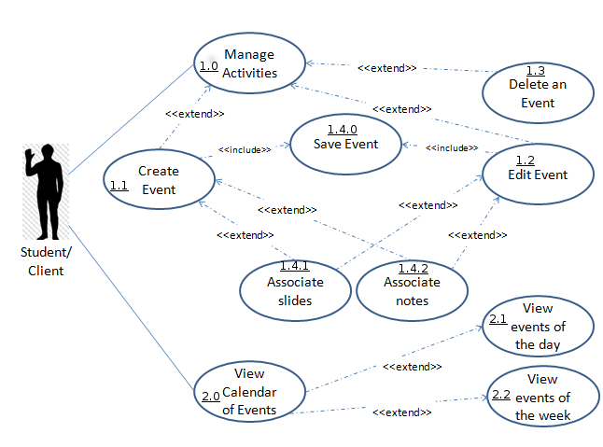

List of Actors:
Actors | Description
Student | the target audience, an entity who uses/interacts with the program

List of Use-cases:
Use-Case | Description
Manage Activities | Overall event handler.
Create event | Create an event that is not yet present in the current events list.
Save event | Saves changes made in an activity or event. Adds the event to the calendar.
Delete an event | Deletes and event and all of its associates(slides, notes …)
Edit event | Modifies an existing event.
Associate slides | Adds an existing slideshow link to the event.
Associate notes | Adds an existing text file path to the event.
View events of the day | Display the events of a particular day.
View events of the week | Display all the events in a particular week.
View calendar of activities | Display all events in a particular month.

